Financial Review Sentiment Analysis Project Report
Objective:
The aim of this project was to analyze the sentiment of financial reviews using Natural Language Processing (NLP) techniques. The goal was to classify sentiments into categories such as positive, neutral, or negative.
Approach:
- Fine-tuned FinBERT, a BERT-based model specifically pre-trained on financial text.
- Used a labeled financial reviews dataset.
- Preprocessed the text data (tokenization, padding, truncation).
- Created an end-to-end pipeline for model training, evaluation, and inference.
Model Performance:
- Achieved 93% accuracy on the validation dataset.
- Visualized performance using a confusion matrix to analyze class-wise prediction results.

Classification Report:
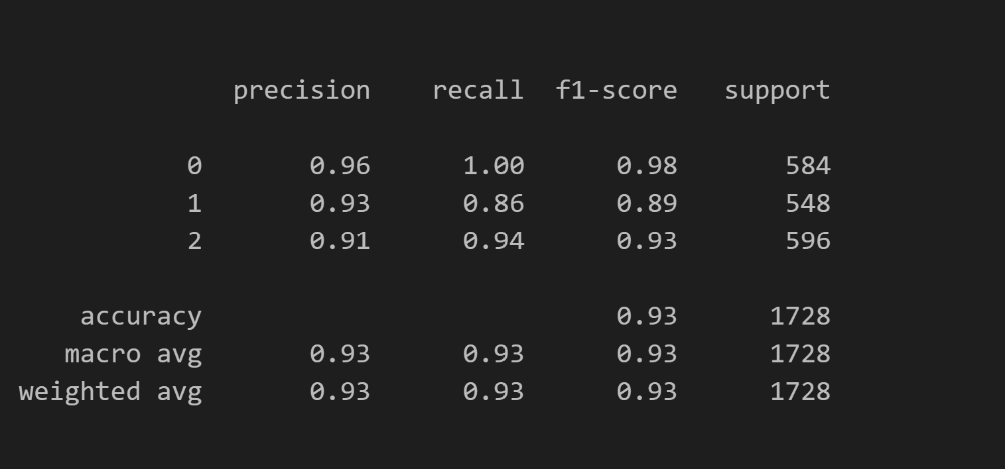

Confusion Matrix:
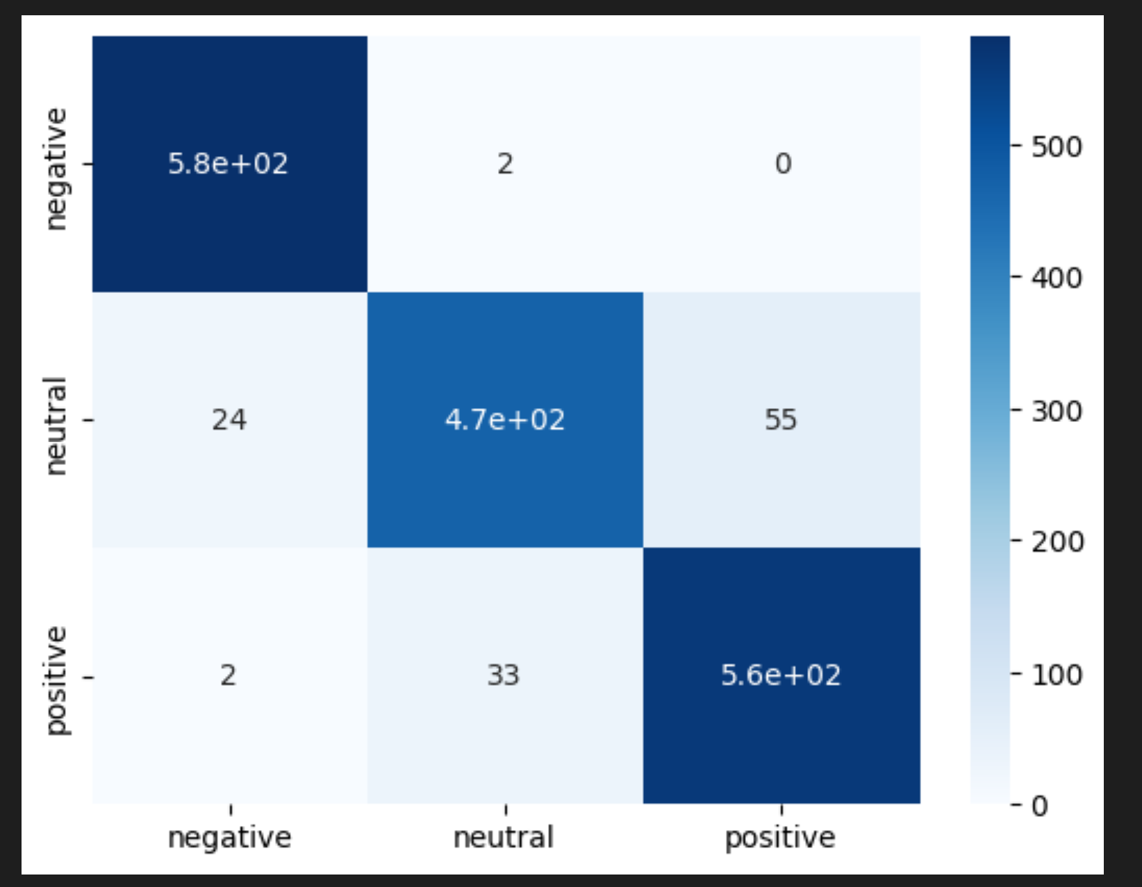
Streamlit UI:
Built a Streamlit application where users can:
- Input a financial review.
- Choose the FinBERT model.
- Get real-time sentiment prediction (Positive, Neutral, or Negative).
- To run stramlit use(streamlit run app.py)
Conclusion:
This project effectively demonstrates how transfer learning with domain-specific models like FinBERT can provide high-accuracy sentiment classification in financial contexts. The interactive Streamlit UI makes it user-friendly and suitable for business insights.

